1. THE COMPANY AND THE PRODUCT

* 1. OVERVIEW

The risk factor is defined as including multiple factors, namely the ingestion of unsafe water, lack of water linked to inadequate hygiene, poor personal and domestic hygiene and agricultural practices, contact with unsafe water, and inadequate development and management of water resources or water systems. In many developing countries, dirty or contaminated water is being used for drinking without any proper former treatment. One of the reasons for this happening is the unawareness of public and administration and the lack of water quality monitoring system which creates serious health issues. Also natural phenomena such as volcanoes, algae tints, rainstorms, and earthquakes also change the quality and ecological status of water.

JAB’s Inc. was founded in the Mandaue City, Cebu, Philippines last March

2019 with our CEO Bernard Panares and co-partnership Jucel Gadiano and Ahrve

Jabonillo. The team had created the Arduino Based Water Quality Tester to offer in

Any company and market who wants to have a comfortable and affordable water quality tester and this project is a portable that easiest to use to those who want to buy in the market or online shopping.

1.2 BUSINESS MODEL

The business model that is use in this project is the business to consumer model.

Business to Customer sometimes refers to the tactics and strategies in which a company promotes its products and services to individual people: creating, advertising, and selling products for customers to use in their everyday lives. The target of the company for this business is the places that have polluted water which might be contaminated and it is not safe for drinking water but the main target of this project are for the hikers, mountain climbing, bikers, and campers.

1.3 THE PRODUCT

JAB Inc. will offer the first portable water quality tester. We created “Arduino Based Water Quality Tester” in terms of water tester, where that you can test the quality of water using this portable or tumbler where that the result will appear in screen after you test the water. It also tests the safeness of water so that you can test the quality of water for safe to drink or not safe to drink. This project has more features to test the water.

1.4 THE PRODUCT VALUE

Here in Cebu, there is a lot of unclean water, such as rainwater, in the river, in the well and because of this, many people get sick from drinking contaminated water and there are areas where there is no technology to purify the water before drinking it. And some tourists like adventure such as hikers, mountain climbing, bikers and campers and sometimes they want to drink water in the river, lake, etc. But we don't know if the water they drink is safe.

But with the JAB Inc. very own a technology the “Arduino Based Water Quality Tester”, the design of our project is tumbler or portable. The places here in Cebu that has contaminated water have a solution to test the water so they can use our project to test the water if safe to drink or not. And it's useful to the adventurers, for a reason this project is portable, hand carry and easy to use for the adventurers. If they want to use this project they need to put water in tumbler afterward it appears on the screen if the water is safe to drink or not and if they want to drink in a river, lake or place that have contaminated water.

1.5 MARKET ENTRY AND GROWTH STRATEGY

Water quality is expected to deteriorate quickly over the next few decades, increasing hazards to human health, financial growth and thousands of aquatic ecosystems in both developed and developing economies. This has led to governments all over the globe to take preventive measure to avoid water shortage and water contamination contingencies, in collaboration with private corporations.

The team will be using Social Medias, Newspapers and advertisements to promote and enforce our product value. The company also plan to expand not just here in VISAYAS but in whole Philippines next year.

2.0 MARKET RESEARCH AND ANALYSIS

2.1 MARKET DEFINITION

JAB Inc. target market is the company that related to the water supply. Research state that there are up to 1.5 million adventurers who visit Cebu last year 2018 itself and 39% of the adventurer are having hard time to get a proper drinking of water, updated and secure information to get their needs like how to taste the water if safe to drink. So our product is fit in this situation for a reason our project is portable and affordable.

2.2 RESEARCH METHODOLOGY

The researchers gather data through testing, user reviews, and questionnaire. The water quality tester methodology that can be applied either on a regional basis or to site-specific, alternative approaches to monitoring the quality of water at a considerable saving of time and money. Extensive detail is given to the relation of water quality to the geohydrology framework, constituents in the polluted water, sources and causes of pollution, and the use of water.

2.3 MARKET SIZE

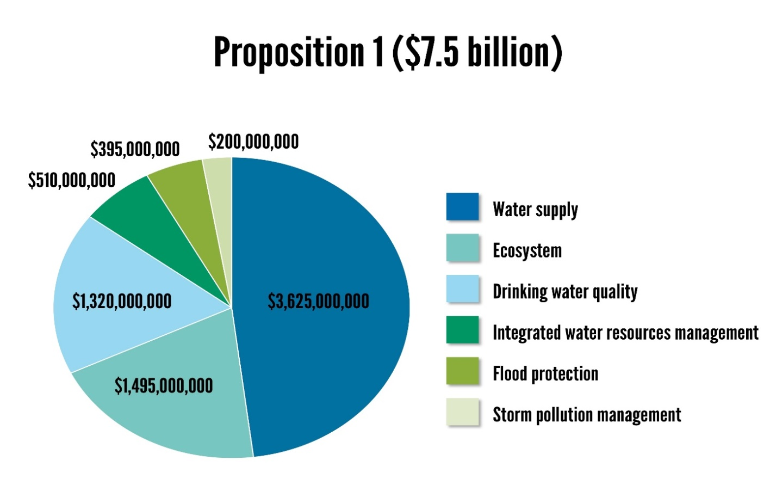Hikers, mountain climbing, bikers and campers is the main target of JAB Inc. Water supplies could also benefit from the $2.7b allocated to groundwater storage projects. It will be generated for the next 4 years in developing educational field and $7.5b in developing retail which the “Arduino Based Water Quality Tester” fit.

2.4 MARKETING STRATEGY

JAB Inc. will be promoting "Arduino Based Water Quality Tester" through social media. The team plan to upload a video trailer in YouTube and Facebook to attract potential costumer since Facebook nowadays are the most common place where advertising tourism is very effective. Our company value customer’s feedbacks and use it to further improve the product quality and experience. We also believe that first impression is very significant for people to try out of our product so we made sure that when a people use the product their first reaction will say “This is the best water tester”.

2.5 COMPETITOR PROFILE

JAB Inc.’s Arduino Based Water Tester will be the first water tester that is portable and easy to carry. Current water tester is available but it will be different of those water testers.

2.6 COMPETITIVE ADVANTAGES

JAB Inc.’s Arduino Based Water Tester is the water tester which can be portable and it will give the quality of the water if it is safe or not safe. Arduino Based Water Tester is very unique and useful because it can really help the user to aware the quality of the water. Our company values user’s comments and suggestions to make it better.

2.7 MARKETING PLAN

JAB Inc. plan is to use the internet to promote and advertise our product. Advertisements have the potential to reach thousand potential customers. Our company also plan on creating a website where users can post their reviews, comments and suggestions about the product. We assumed that the product will increase at least 30% every year. JAB Inc. ensures the customer quality product, good service, secure online transactions and fast delivery. The Company’s revenue will be able to compensate for the operating expenses and other related expenses and will still able to generate a fair amount of profit.

1. FINANCIAL STATEMENTS

JAB Inc. assumed that there will be no financial problems encountered in the next 4 yrs. We also assumed the positive response of the users on the product Arduino Based Water Tester.

The financial projections show that in the 4 years that the business will continue to have a positive profit.

4. DESIGN AND DEVELOPMENT PLANS

4.1 DEVELOPMENT STATUS AND TASKS

Arduino Based Water Tester is still the development status. We are gathering more information that will satisfy the goal of the product. We are studying on how the product will exist on the market and how will be our product will be different.

4.2 CURRENT DESIGN GOALS

The company’s current goal is to gather information, advertise and the product out in the market, where the customers will able to see or hear. This will be a great impact on the company and with that it will expand a bigger market size.

4.3 DIFFICULTIES AND RISKS

Difficulty in this product will be the materials that inserted on it and how will the customer likes the product. Potential small businesses must be able to convince potential investor(s) about his/her own business idea. This is very challenging because you are trying to sell to your potential investor(s) something which does not exist yet.

4.8 PRODUCT IMPROVEMENT AND NEW PRODUCTS

JAB Inc. can accept customer’s feedbacks so that if there is need to be improved in our product, our company will work for it for the satisfaction of our customers. Although marketing and advertising are very important to get more customers, quality, service and customer’s satisfaction are what will keep our business successful in the long run.

4.9 PROPRIETARY ISSUES

There are no legal issues in our prototype. We are not developing other’s proprietary technologies for our own gain. Our competitors may have the same idea but we have our own features that cannot copy our own prototype.

5. MANUFACTURING AND OPERATIONS PLAN

5.1 DEVELOPMENT STATUS: ALPHA PROTOTYPE

Our group is composed of skilled of programmers that can build the success and invent Arduino Based Water Quality Tester in our company. Each programmers have plays a big role in making the product. The prototype was successfully finished, even though there is some problem that needs to be fixed, but we can assure that it will be solved after we released the prototype in the market. The cost of the parts of the prototype is preferably favorable in the market.

5.2 STRATEGY AND PLANS: PRODUCTION MODEL

Water Quality Tester it is not new to us nowadays but we have not yet explored the full potential of it. We think through the helps of this device and what we develop here at JAB Inc. we will be able to look at the quality of the water if it is safe drinking or not safe in drinking. The device will be available on the market as soon it’s done. One of our goals is to make this product make easier to bring and less hassle. And by the means of production lead time, we can guarantee that our product from our Company will be there right on times for the customers. We keep in our mind that it is always an advantage to have a fast response and smooth transaction to our beloved customers when they place orders.

6. MANAGEMENT TEAM

JAB Inc.is created with healthy issues that will secure the health of people. Our company is run by Computer Engineers namely Engr. Benny Pañares, Engr. Ahrve Kim Jabonillo and Engr. Jucel A. Gadiano who are the Chief Executive Officer, Chief Technology Officer and Chief Operating Officer of the company respectively. They are all experienced web developer and programming. JAB Inc. will hire additional programmers and marketing experts and chemical experts to assure the growth of the company.

**Engr. Benny Pañares**

Engr. Benny Pañares is the Chief Executive Officer of JAB Inc. He is the one who is responsible for everything. He ensure the all the requirements, administration, hiring and firing and legal matters. He graduated with a Bachelor Degree and Computer Engineering from University of Cebu, Philippines.

**Engr. Ahrve Kim Jabonillo**

Engr. Ahrve Kim Jabonillo is the Chief Technology Officer. He conducts research to improve the technological assets of the company and developing strategic plans and setting timelines for deployment of all technical. He graduated with a Bachelor Degree and Computer Engineering from University of Cebu, Philippines. And also learned to be a Web Developer and was able to apply in the company

**Engr. Jucel A. Gadiano**

Engr. Jucel A. Gadiano is the Chief Operating Officer. She is responsible our company’s operations especially in sales, marketing, finance and lead co-workers to encourage maximum performance and dedications. She graduated with a Bachelor Degree and Computer Engineering from University of Cebu, Philippines. And she has been the essential of the company to maintained marketing strategies.